Group-9

Ride Sharing System

Contents
Project Description 3
Objectives 3
Scope 4
Database Requirements 4
User Requirements 5
Business Rules 5
Entity Relationship Diagram 6
Data Dictionary 7

Project Description:
This project will develop a robust and scalable relational database system for a web-based ride-sharing service like Uber or Lyft. The database will handle data regarding drivers, passengers, trip bookings, ride histories, payments, and driver ratings. It should ensure smooth integration with the web and mobile applications used for real-time booking and interaction, maintaining data integrity and security. The platform will be targeted at an international audience, supporting multiple languages and currencies, and will be designed for high-traffic, enterprise-level operations.

Objectives:
- Organize and structure data in a way that will enable the operation of a ride-sharing platform to function smoothly.
- Ensure up-to-date trip bookings and transactions in real time.
- Ensure that data integrity and security are maintained about sensitive data that may include payment details.
- Track detailed histories of rides, enabling ratings by passengers and drivers.
- Support role-based access control: a user can be a driver, a passenger, or an administrator, depending on the type of access he needs.
- Allow scalability to handle more and more users and their on-ride transactions.

Scope:
This database system will introduce the backbone for a web-based, enterprise-level ride- sharing application. The database will manage:
- Driver and Passenger Profiles: Record personal information, registration data, and individual preferences.
- Trip Bookings: Handling demands for trips, real-time updating, assigning rides, and fare calculation.
- Ride History: This is the general tracking of past trips of both drivers and passengers, inclusive of location information, time, and ratings.
- Payment Processing: Handling fare calculations and managing payments using multiple payment methods and currencies.
- Ratings and Feedback: Allows passengers to rate drivers and submit feedback post- trip.
- Administrative Interface: Provide the administrators with the facility to track the activity happening on the platform, resolve disputes, if any, and ensure policy compliance.

Project Requirements:
- Scalability: The system must be designed to handle a growing number of users and transactions, particularly during peak hours.
- Concurrency: The database must support multiple concurrent connections without performance degradation.
- Data Integrity: The system must enforce data consistency, ensuring that no data conflicts arise during simultaneous operations.
- Role-Based Access Control: Different users (drivers, passengers, administrators) will have role-specific access to different types of data.
- Security: Security related to sensitive information, such as payment data, will be encrypted, and access will only be given to those authorized.
- Backup and Recovery: These include regular backup of data and following a disaster recovery process to avoid data loss.
- Multi-Currency Support: The database should have support for multiple currencies to manage the various payments emanating from transactions created within multiple markets globally.
- Multi-Language Support: The platform should provide support for multiple languages with respect to the user interface.
- Real-Time Updates: The system should update trip bookings and any status changes in real time.
- Historical Data Management: Records of all rides, including trip details, fares breakdowns, and interactions between drivers and passengers, should be stored in the system.

Database Requirements:
  - Driver and Passenger Data: Storing user profiles, including personal information and preferences.
  - Trip Booking Data: Real-time management of bookings regarding trips -origins, destinations, times, and status changes.
  - Payment Data: Processing payments, supporting multiple payment methods, and storing transaction histories.
  - Ratings and Feedback: Passengers rate the drivers and vice versa, along with comments.
  - Role-Based Access Control: Identifying users based on their roles in the system, such as driver, passenger, and admin, and controlling their permissions accordingly.

  - Transaction Logs: Records of different system transactions, such as bookings, payments, and cancellation of courses.

User Requirements:
- Historical Ride Tracking: Maintain an extensive history of rides taken by both drivers and passengers, along with details of the trip and ratings.
- Profile Management: Allow drivers and passengers to create and manage their profiles, updating contact information and preferences.
- Real-Time Booking: Enable passengers to book rides in real time and receive updates on their trip status.
- Payment Processing: Support multiple payment methods and currencies, ensuring secure and efficient transactions.
- Driver Ratings: Allow passengers to rate drivers and give them feedback. Allow drivers to update their availability status in real time.
- Driver Availability: Allow drivers to update their availability status in real time.
- Passenger Ride History: Passengers can view their past rides and access trip details.
- Multi-Language and Currency: Provide multilingual support to cater to a wider audience across the globe and for the support of various types of currencies across different parts of the world.
- Administrative Monitoring: Administrators can monitor platform activity, resolve disputes, and manage user access.
- Security and Encryption: Sensitive data, especially payment information, must be encrypted, and only authorized personnel can access it.

Business Rules:
- One driver can accept no more than one trip at a time.
- A passenger can only book one trip at a time.
- A ride will be only considered complete when the driver marks the ride as complete.
- Payment is processed only after the ride has completed.
- Drivers must maintain an average rating of 4.0 or more to continue being active on the platform.
- After a trip, passengers rate drivers but have no access to a driver's information beyond what is needed to take the trip.
- Drivers do not have access to the passenger's details, except their name and the locations of pick-up and drop.

- Drivers may set their status regarding availability but must complete accepted trips before updating the status.
- If there are passenger cancellations, there is a fee incurred when cancelled in less than 5 minutes of the allotted time.
- Administrators can suspend or ban users from violating platform policies.

Entity-Relationship Diagram (ERD):

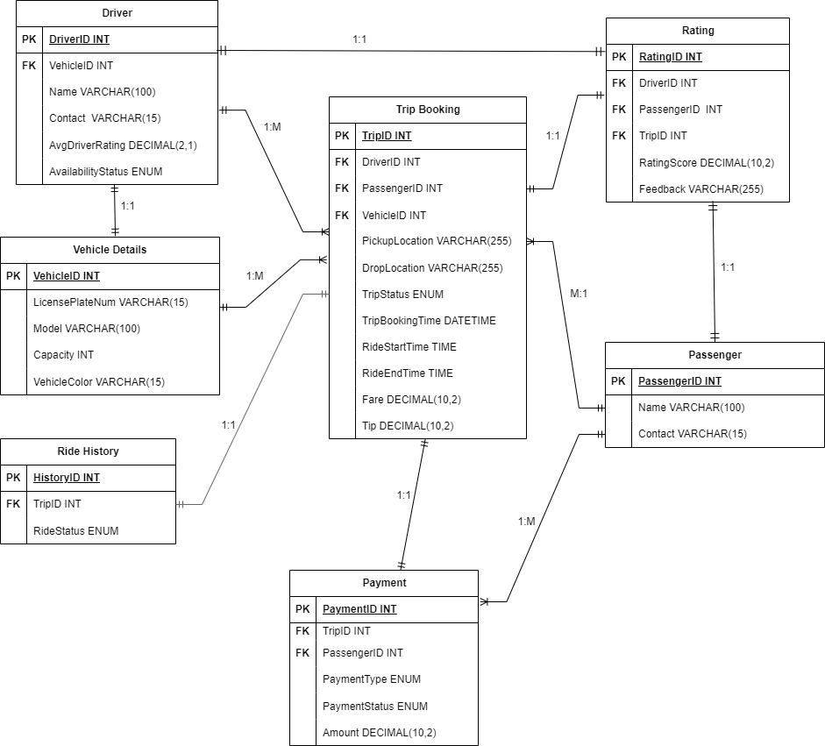

Entities:
- Driver
- Passenger
- Trip Booking
- Ride History
- Payment
- Rating
- Vehicle Details

Relationships:
  - The driver has many Trip Bookings.
  - Passengers have many Trip Bookings.
  - Trip Booking generates one Ride History.
  - Payment is associated with one Trip Booking.
  - The rating can be given by Passenger for Driver after a Trip.
  - A vehicle can be associated with many trip bookings, but each trip booking is associated with only one vehicle.

Data Dictionary:
- Driver.

Table Name | Attribute Name | Description | Data Type | Data Format | Required | PK Or FK | Example
Driver | Driver ID | Unique Identifier for Driver | INT | 999999 | Yes | PK | 434335
 | Name | Name of the Driver | Varchar (20) | Xxxxxxx | Yes |  | James Smith
 | Contact | Contact number of the driver. | Varchar (15) | Xxxxxxx | Yes |  | 123-410-9988
 | VehicleID | The ID of the vehicle assigned to the driver | INT | 9999 | Yes | FK | 99999
 | AvgDriverRating | Average rating of the driver. | Decimal (2,1) | 5.0 | Yes |  | 4.8
 | Availability Status | Availability status (available or unavailable). | ENUM ('Available', 'Unavailable') | Available | Yes |  | Available
 | DriverAccountStatus | Status of driver Acount. | ENUM(‘Active’, ‘Suspended’, ‘Banned’) | Active | Yes |  | Active

- Passenger:

Table Name |  | Attribute Name | Description |  | Data Type | Data Format | Required | PK Or FK | Example
Passenger |  | Passenger ID | Unique Identifier for passenger |  | INT | 999999 | Yes | PK | 233333
 |  | Name | Name of the passenger |  | Varchar (20) | xxxxxxx | Yes |  | Andrew Kevin
 |  | Contact | Contact number of the passenger. |  | Varchar (15) | 99999999 | Yes |  | 123-193-9728
 | PassengerAccountStatus |  |  | Status of passenger Acount. | ENUM(‘Active’, ‘Suspended’, ‘Banned’) | Active | Yes |  | Active

- Trip Booking:

Table Name | Attribute Name | Description | Data Type | Data Format | Required | PK Or FK | Example
Trip Booking | TripID | Unique Id for trips | INT | 2334344  34 | Yes | PK | 23343443  4
 | DriverID | Unique Id for Driver | INT | 3454444  433 | Yes | FK | 34544444  33

 | PassengerID | Unique Id for Passenger | INT | 4444345  334 | Yes | FK | 44443453  34
 | VechileID | The ID of the vehicle assigned to the driver | INT | 34657 |  | FK | 766767
 | PickupLocation | Pickup location for the ride | Varchar  (255) | xxxxxxx | Yes |  | Washingt on Blvd
 | DropLocation | Dropoff location for the ride | Varchar (255) | xxxxxxxx | Yes |  | NewYork St
 | TripStatus | Status of the booking (e.g., 'Pending', 'Completed', etc.). | Enum (‘Pending’, ‘InProgress’, ‘Completed’) | InProgress | Yes |  | Progress
 | TripBookingTime | Time when the booking was made | DATETIME | YYYY-MM-DD T h:mm: ss | Yes |  | 2021-02-11 T 19:12:22
 | RideStartTime | Time when the ride started | DATETIME | YYYY-MM-DD T h:mm: ss | Yes |  | 2021-02-11 T 19:22:22
 | RideEndTime | Time when the ride ended | DATETIME | YYYY-MM-DD T h:mm: ss | Yes |  | 2021-02-11 T 19:52:22
 | Fare | Total Price of Ride | Decimal (10,2) | 999.99 | Yes |  | 40.08$
 | Tip | Tip for the driver | Decimal (10,2) | 999.99 | Yes |  | 10.08$

- Ride History:

Table Name | Attribute Name | Description | Data Type | Data Format | Required | PK Or FK | Example
Ride History | HistoryID | Distinct Previous Ride Identifier | INT | 4444345  33 | Yes | Pk | 45544444  44
 | TripID | Unique Trip Identifier | INT | 8898878  88 | Yes | FK | 55444444  44
 | RideStatus | It indicates the status of ride (eg., ‘completed’ or ‘cancelled’) | ENUM(‘Inprocess’ , ‘Completed’ , ‘Pending’) | xxxxxx | Yes |  | Completed

- Payment
Table Name | Attribute  Name | Description | Data Type | Data Format | Required | PK Or FK | Example
Payment | PaymentID | Unique Identifier for Payment | INT | 7574834  77 | Yes | Pk | 64646464  64
 | TripID | Unique Identifier for Trip | INT | 7574874  74 | Yes | FK | 74747474  74
 | PassengerID | Unique Identifier for Passenger | INT | 8574847  47 | Yes | FK | 57484848  44
 | Payment Method | Payment method used (e.g., "Credit Card") | ENUM  (‘Credit’ , ‘Debit’) | Xxxxxxx | Yes |  | Credit
 | PaymentStatus | Enum to indicate payment status (e.g., "Completed", "Pending", "Failed") | ENUM (‘Completed’, ‘Pending’, ‘Failed’) | Completed | Yes |  | Completed
 | Amount | Total Amount of Ride | Decimal (10,2) | 99.99 | Yes |  | 50.02$

- Rating:

Table Name | Attribute Name | Description | Data Type | Data Format | Required | PK Or FK | Example
Rating | RatingID | Unique Identifier for Rating | Int | 7474773  73 | Yes | PK | 87574874  74
 | DriverID | Unique Identifier for Driver | Int | 8474747  47 | Yes | FK | 84848484  84
 | PassengerID | Unique Identifier for Passenger | Int | 8487484  84 | Yes | FK | 98584848  48
 | TripID | Unique Identifier for Trip | Int | 8584848  48 | Yes | FK | 84848484  84
 | RatingSc ore | Rating given by the passenger (1-5) | Decimal (2,1) | 4.9 | Yes |  | 5.0
 | Feedbac k | Review of the ride | Varchar (255) | xxxxx | No |  | The driver is experiened and dropped me on time.

- Vehicle Details
Table Name | Attribute Name | Description | Data Type | Data Format | Required | PK Or FK | Example
Vehicle Details | VehicleID | Unique identifier for the vehicle | Int | 7474773  73 | Yes | PK | 87574874  74
 | LicensePlateNum | Vehicle license plate number | Varchar (15) | XX34XX3733 | Yes |  | TX53JJ3667
 | Model | Vehicle model (e.g., Corolla) | Varchar (20) | xxxxxx | Yes |  | Corolla
 | Capacity | The number of passengers the vehicle can carry | Int | 9 | Yes |  | 6
 | VehicleColor | Color of the vehicle | Varchar (15) | xxxxxx | Yes |  | Red

Creation of tables and data entry:

Vehicle Details Table:
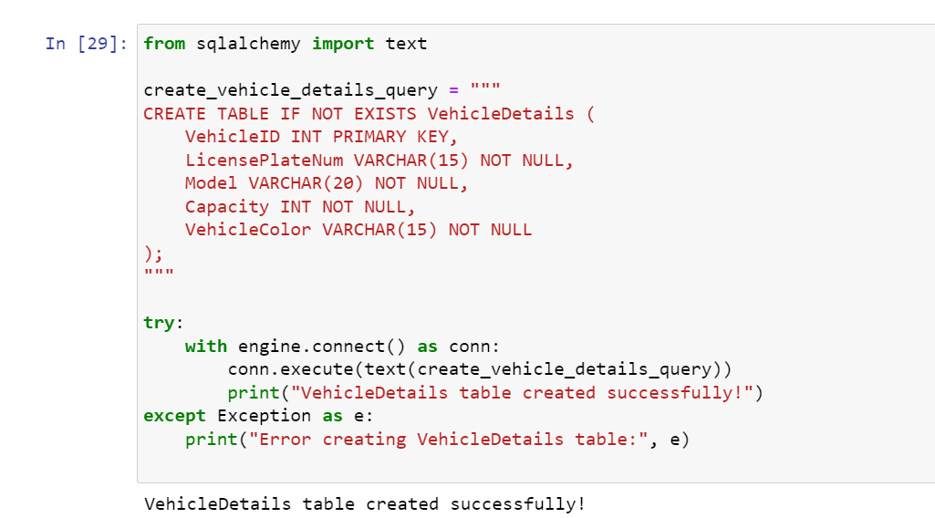
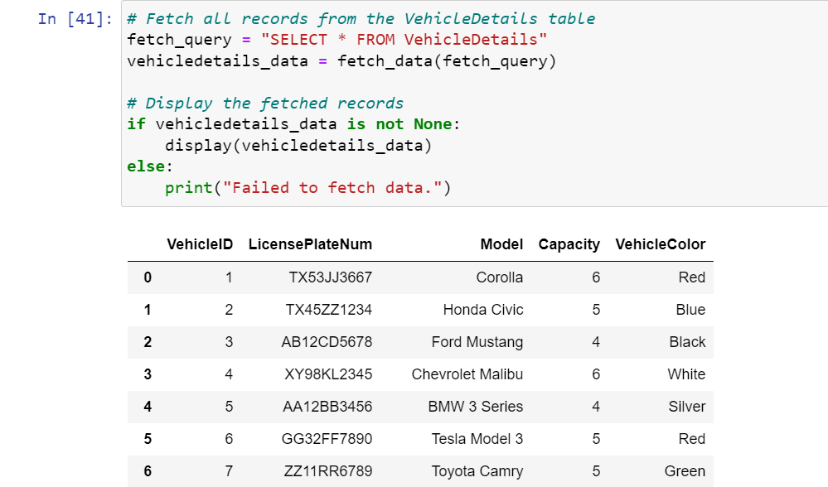

Driver Table:

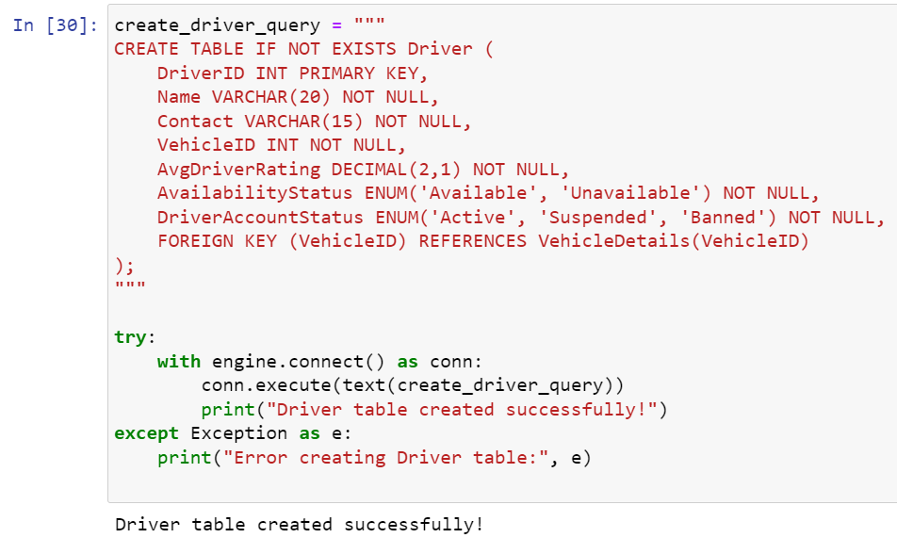
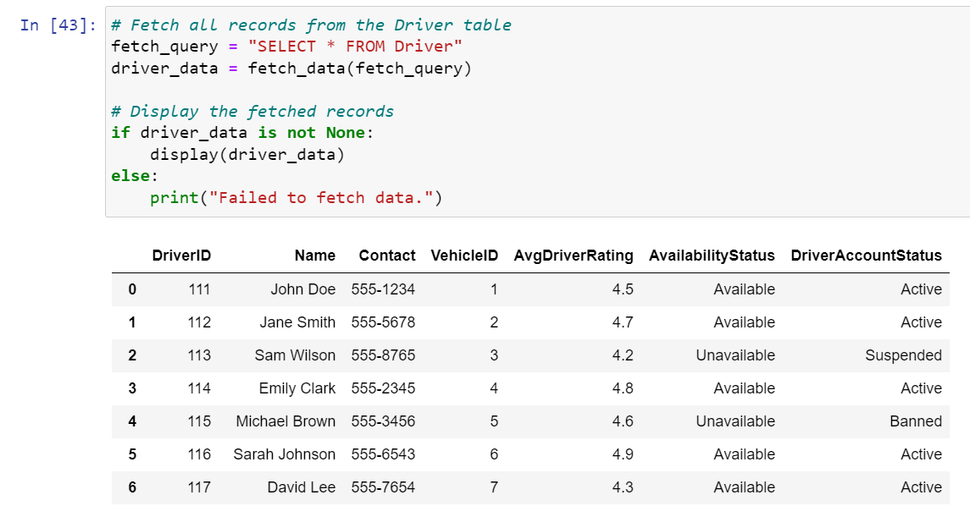
Passenger Table:
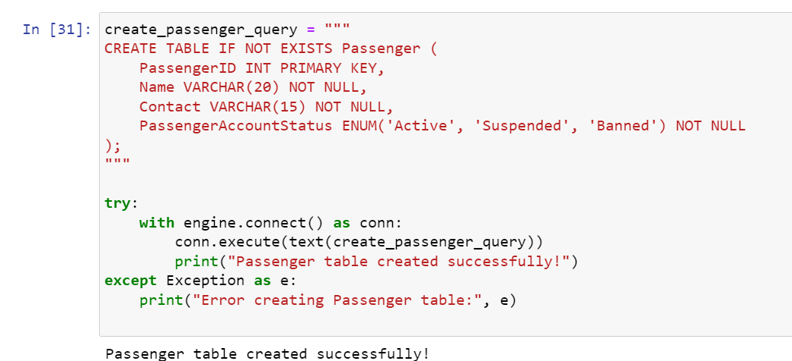
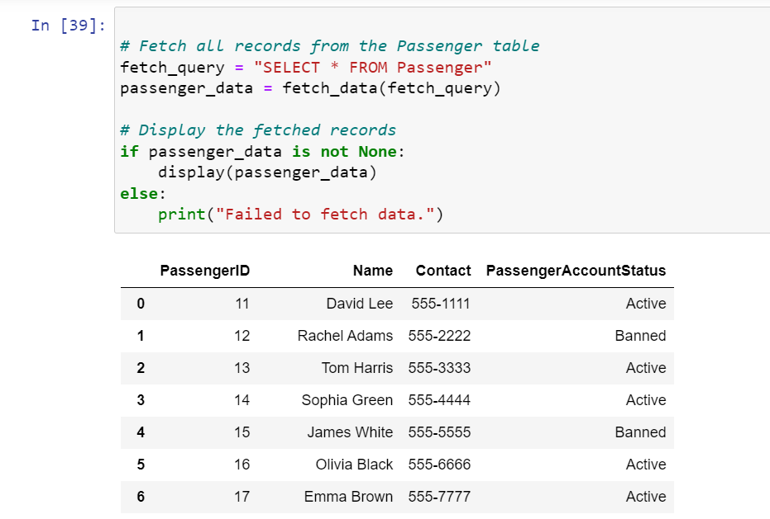

Trip Booking Table:
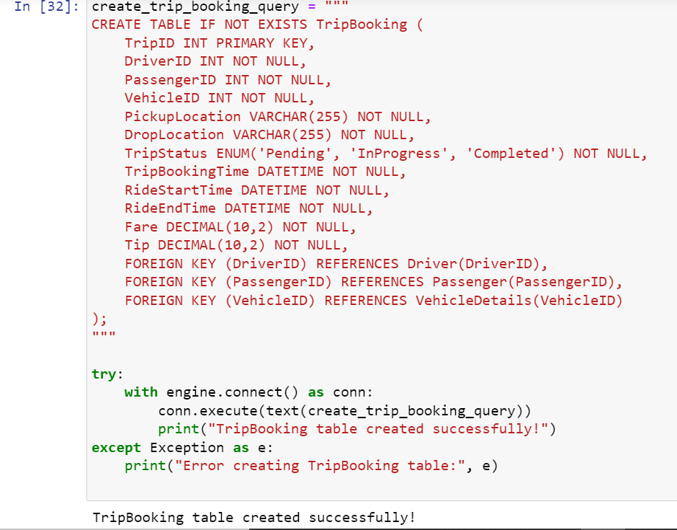
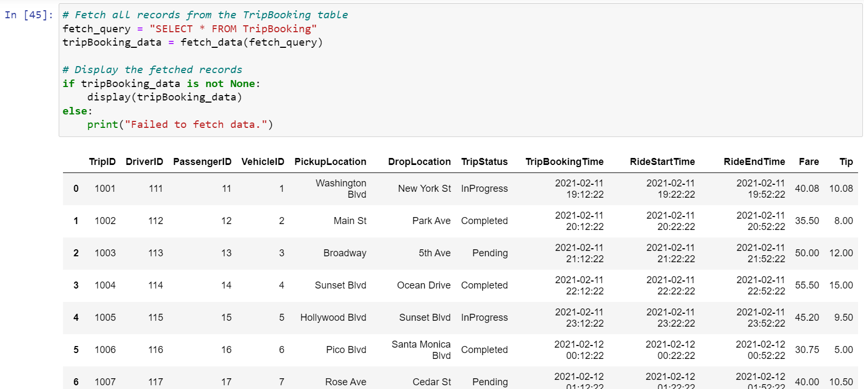

Ride History Table:

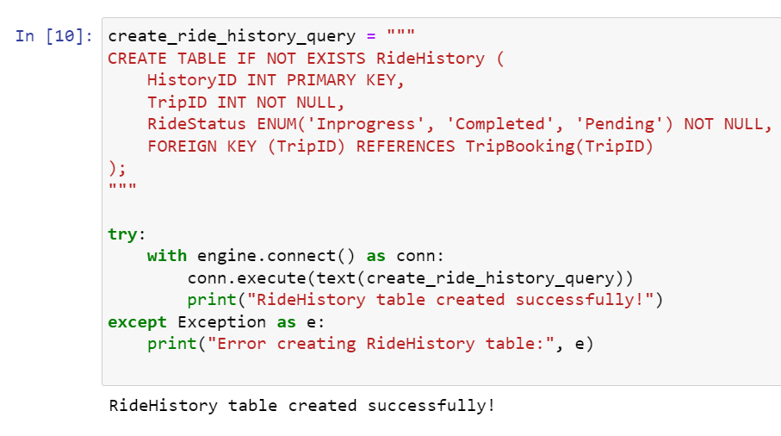

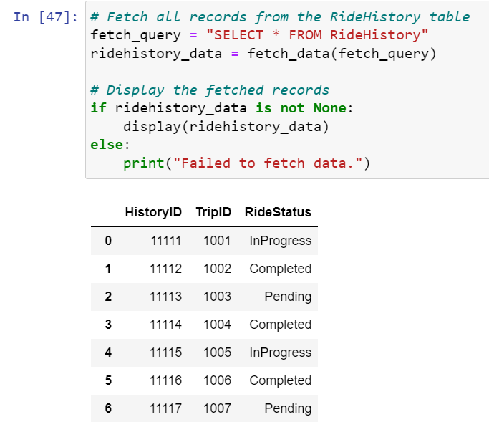

Payment Table:

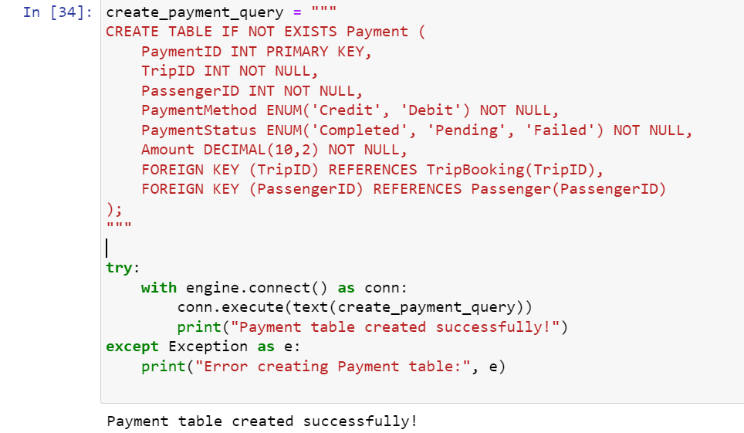
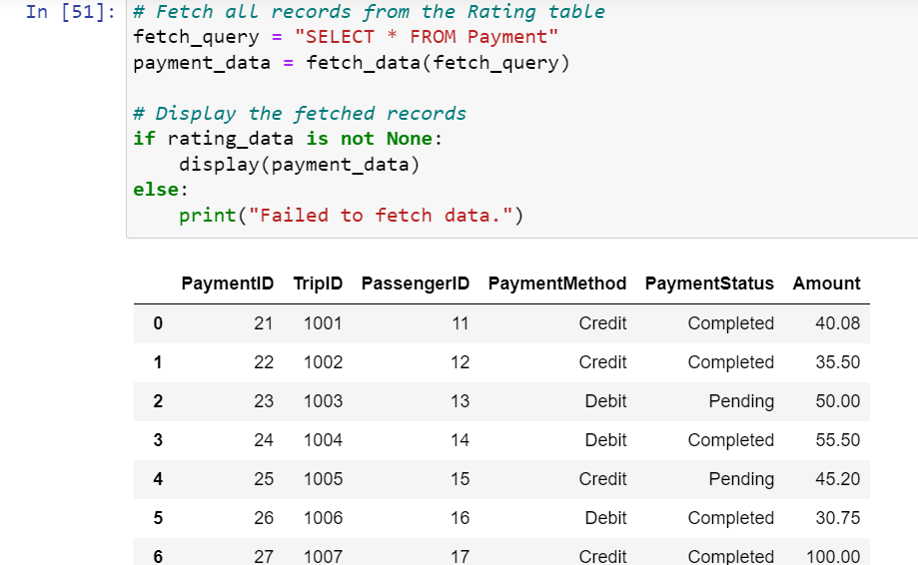

Rating Table:

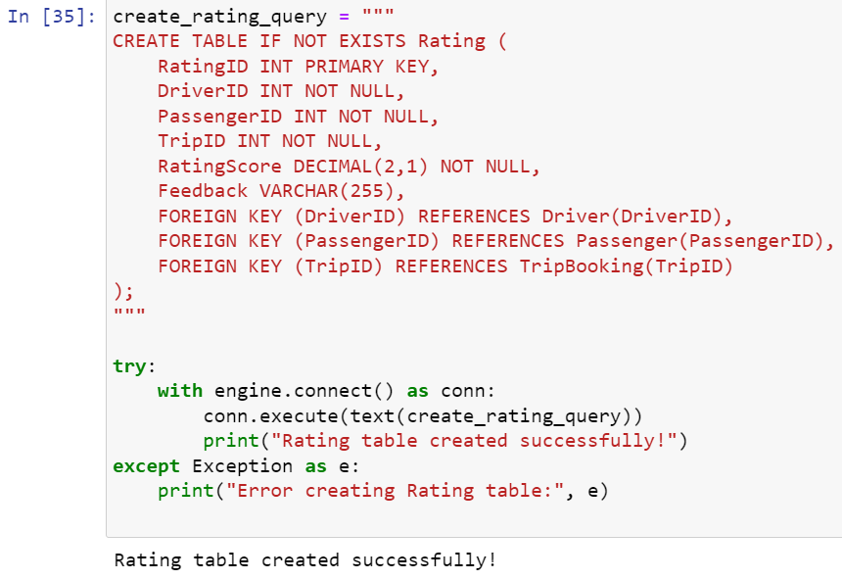
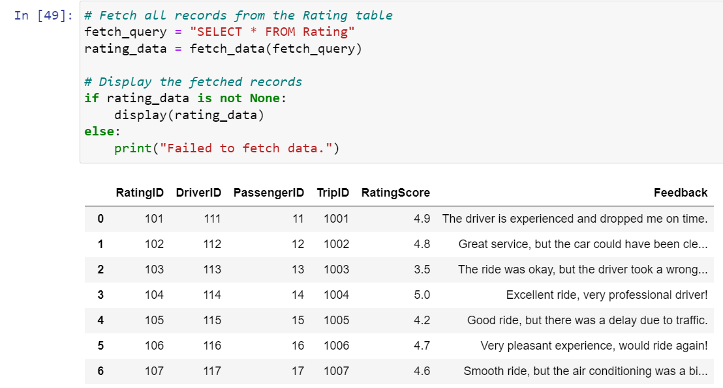

Queries:

Retrieve Trip Details with Associated Driver, Passenger, Vehicle, and Payment Information
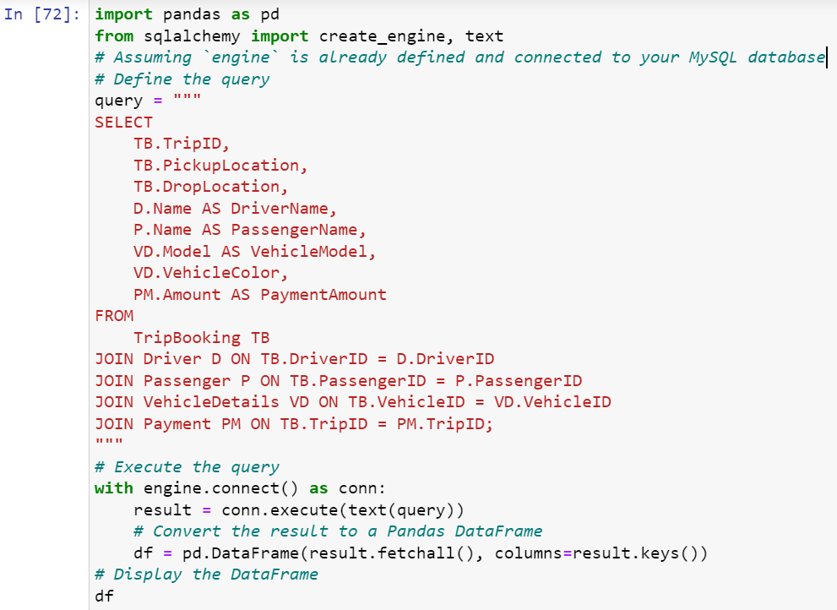
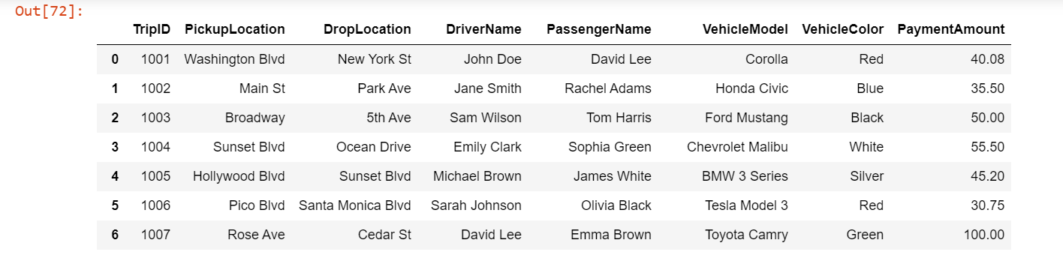

List Completed Trips with Feedback and Ratings

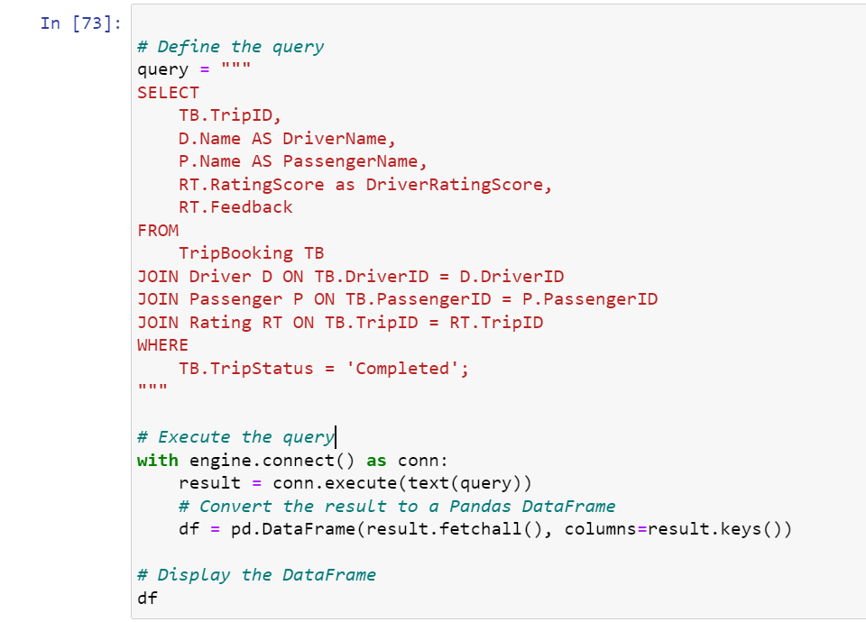
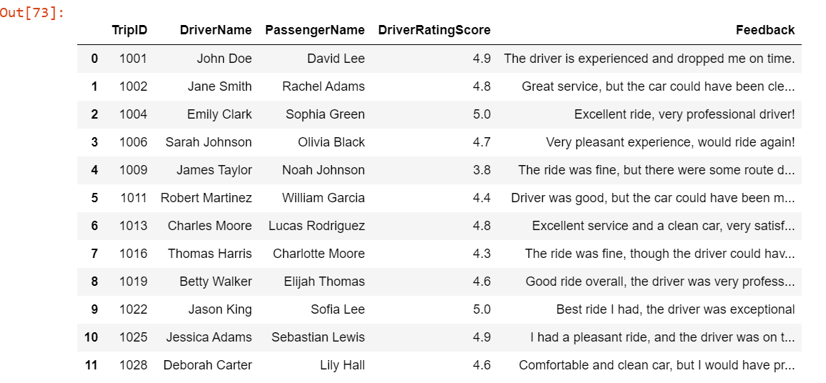

Find Total Earnings for Drivers, Grouped by Driver Name

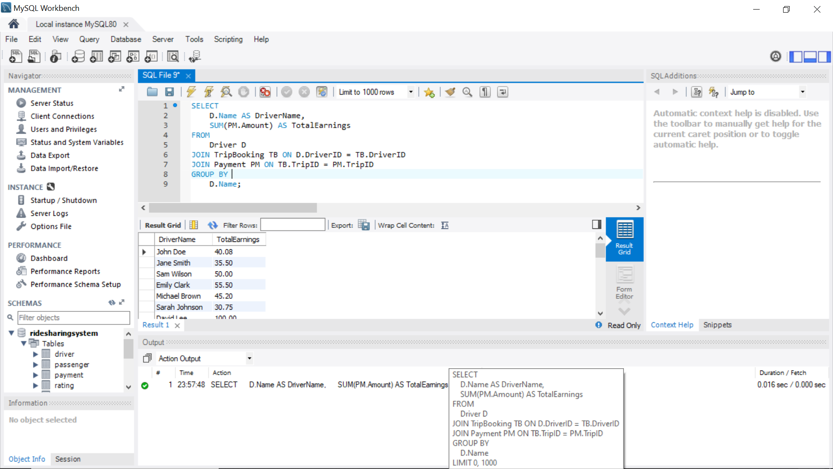

Count Completed Trips for Each Vehicle

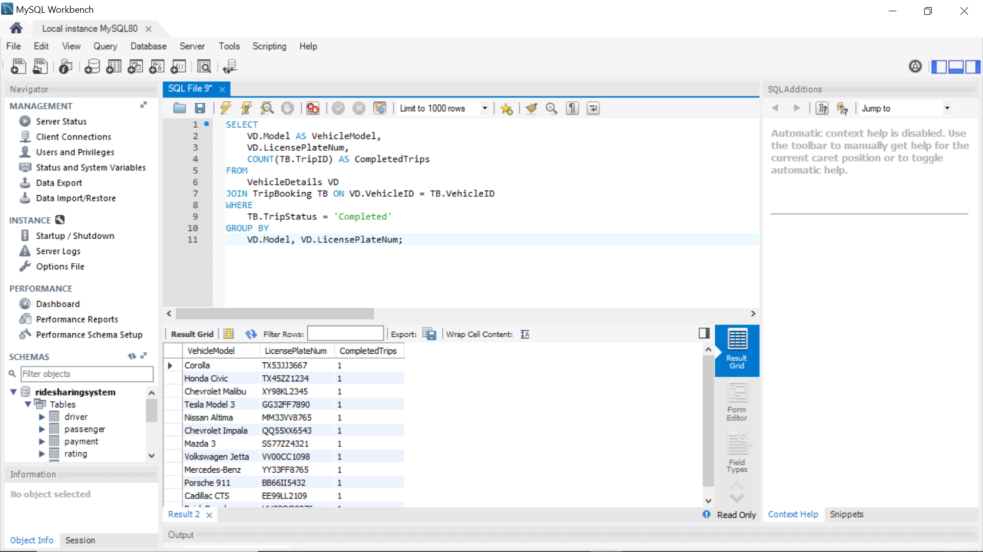

List Active Drivers with Their Average Ratings and Ride History Count

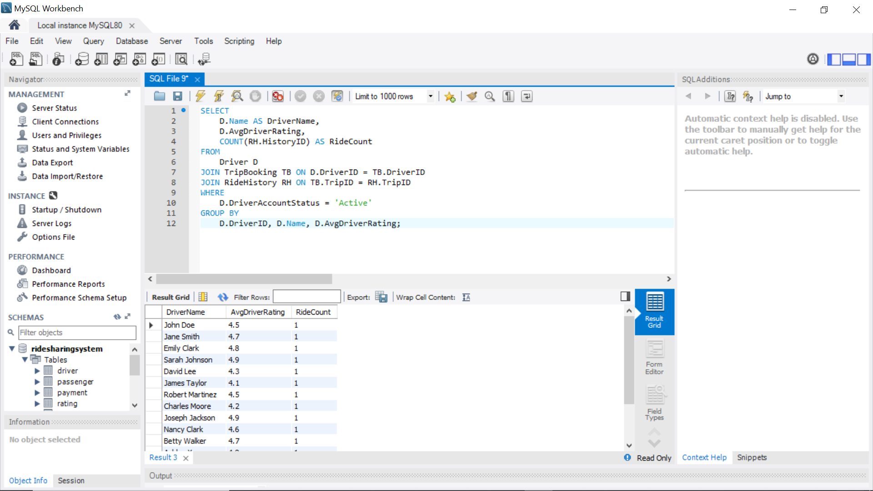

Retrieve Trip Information with Payment and Rating Details

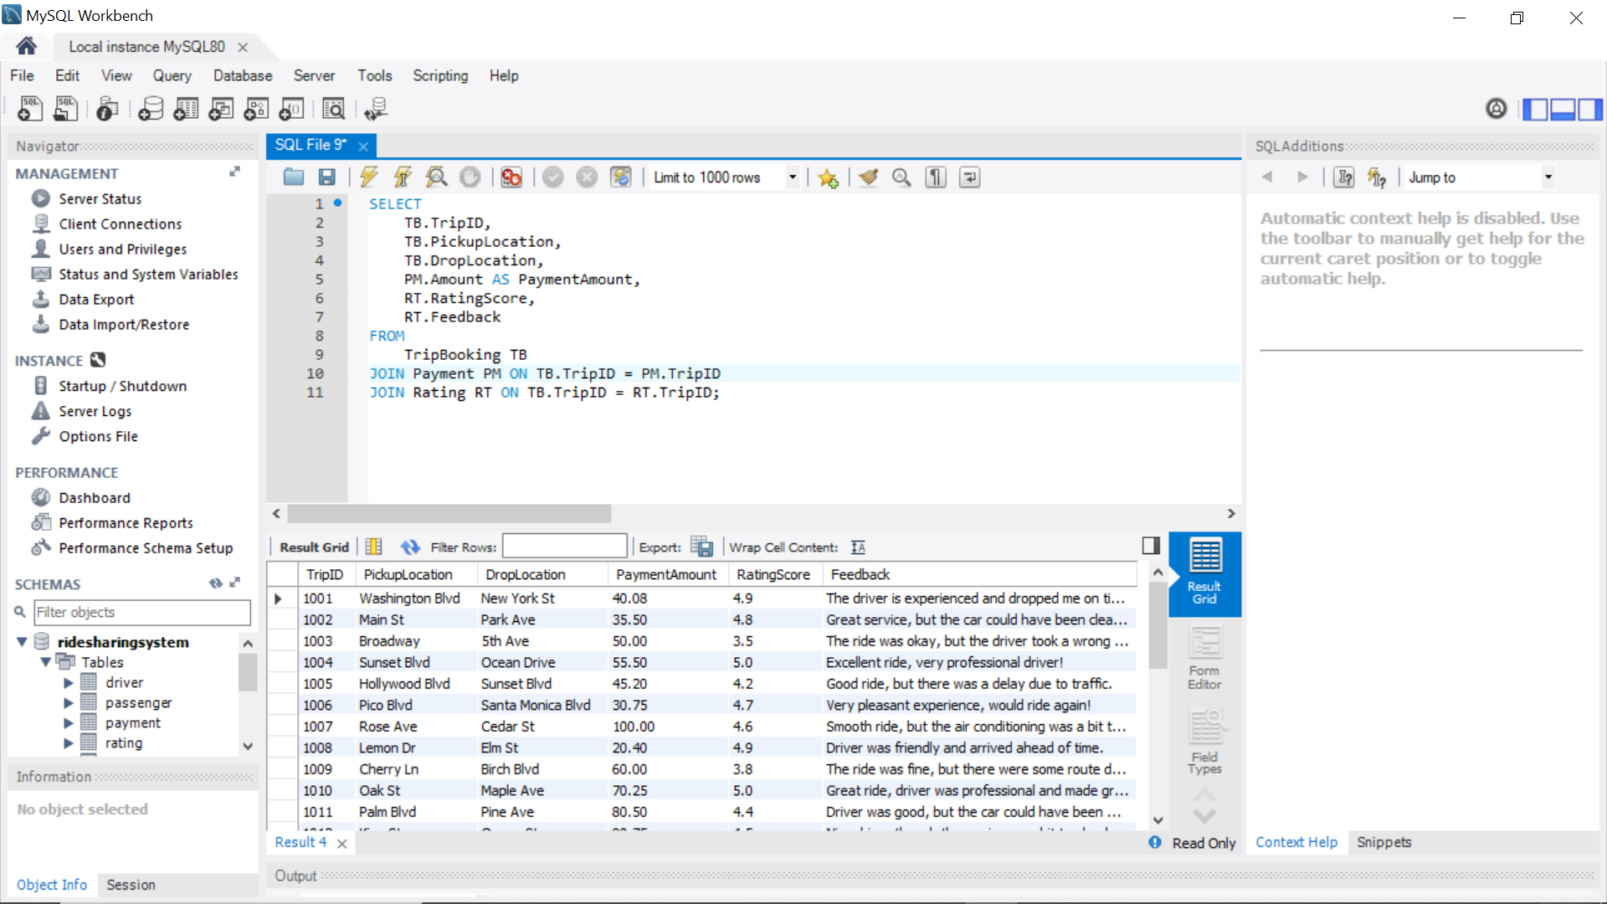

Identify Drivers With Low Ratings and Their Completed Trips

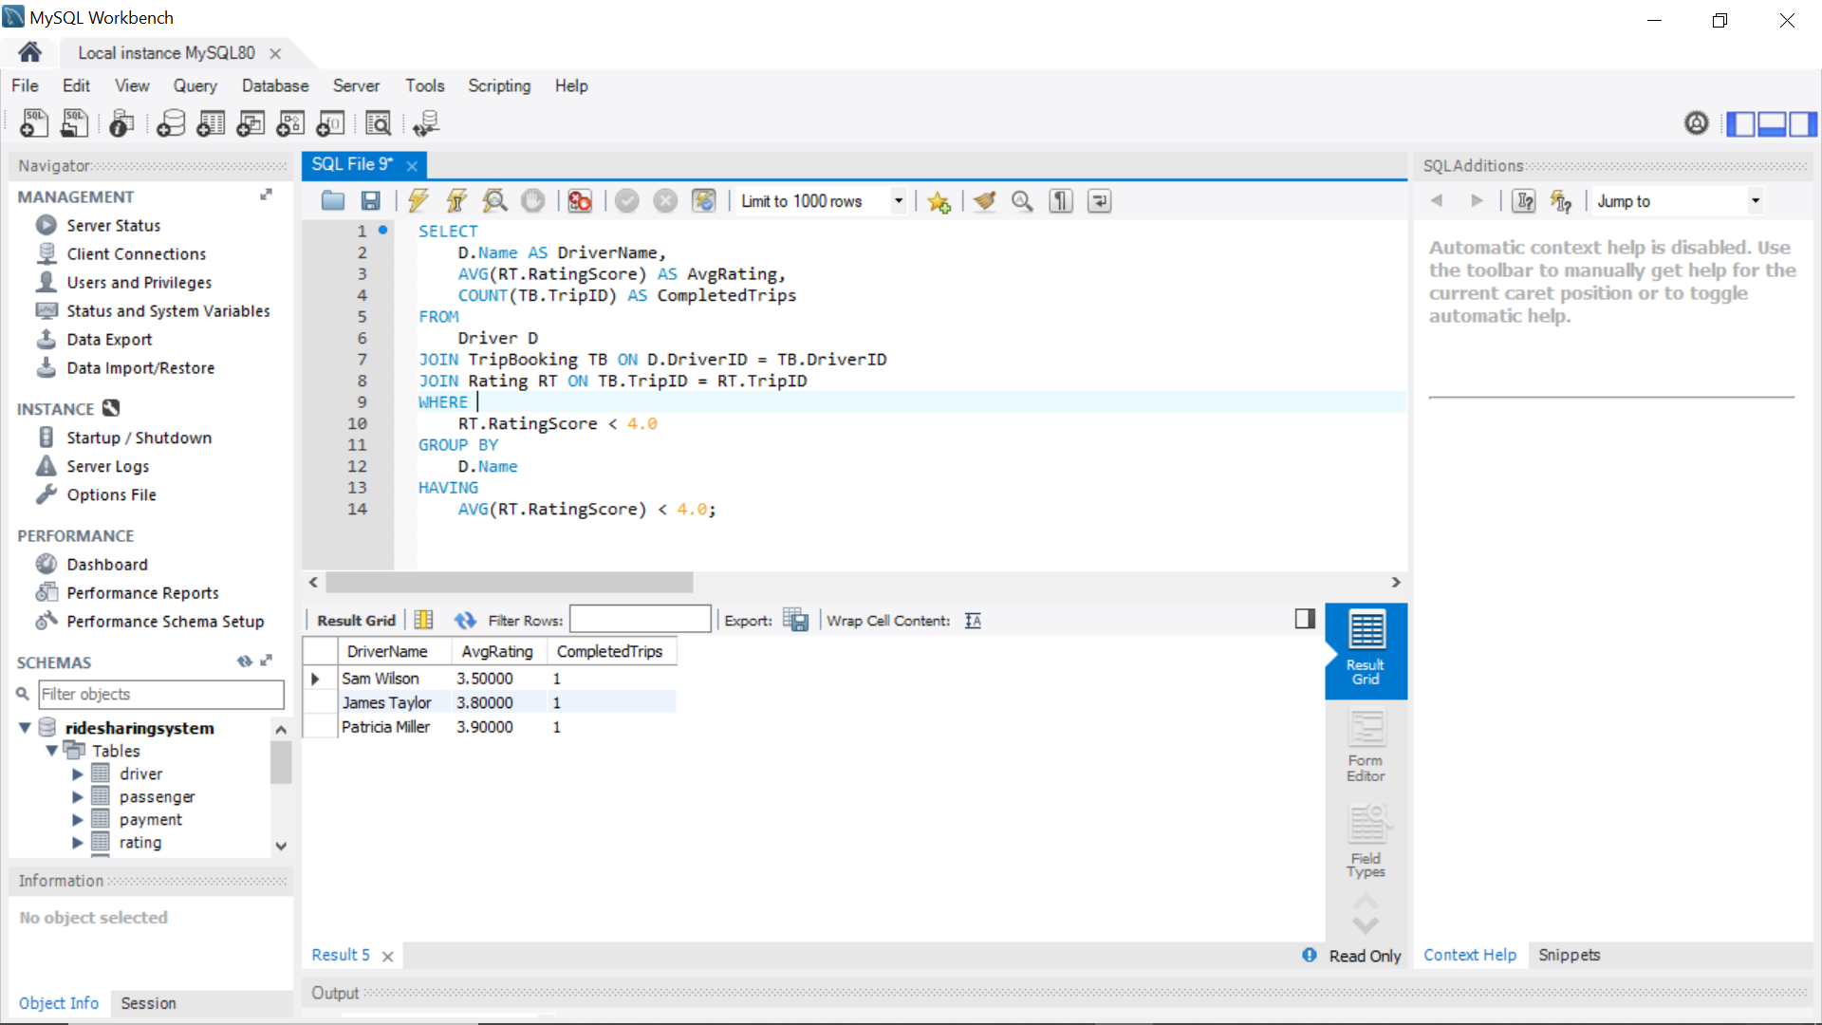

Retrieve a Summary of Trips Grouped by Drivers and Payment Status

